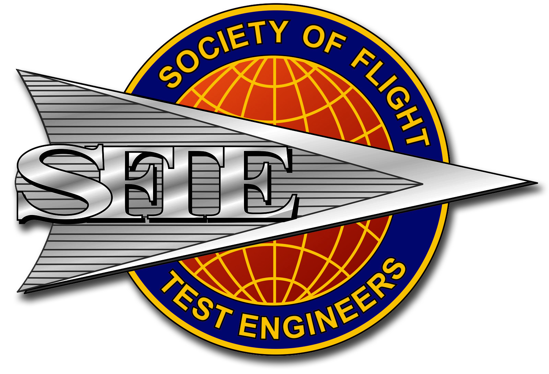

Flight Test Engineering

**Reference Handbook**

Third Edition